**Section 0**

NIKITA@DESKTOP-SVSPKEC MINGW64 ~ (master)

$ mkdir project_dir

cd

NIKITA@DESKTOP-SVSPKEC MINGW64 ~ (master)

$ cd project_dir

NIKITA@DESKTOP-SVSPKEC MINGW64 ~/project_dir (master)

$ git init

Initialized empty Git repository in C:/Users/NIKITA/project_dir/.git/

NIKITA@DESKTOP-SVSPKEC MINGW64 ~/project_dir (master)

$ touch index.html

NIKITA@DESKTOP-SVSPKEC MINGW64 ~/project_dir (master)

$ git status

On branch master

No commits yet

Untracked files:

(use "git add <file>..." to include in what will be committed)

index.html

nothing added to commit but untracked files present (use "git add" to track)

NIKITA@DESKTOP-SVSPKEC MINGW64 ~/project_dir (master)

$ git add index.html

NIKITA@DESKTOP-SVSPKEC MINGW64 ~/project_dir (master)

$ git commit -m "committing index.html"

[master (root-commit) 0b82f6b] committing index.html

1 file changed, 1 insertion(+)

create mode 100644 index.html

NIKITA@DESKTOP-SVSPKEC MINGW64 ~/project_dir (master)

$ touch info.txt

NIKITA@DESKTOP-SVSPKEC MINGW64 ~/project_dir (master)

$ git rm --cached index.html

rm 'index.html'

NIKITA@DESKTOP-SVSPKEC MINGW64 ~/project_dir (master)

$ git status

On branch master

Changes to be committed:

(use "git restore --staged <file>..." to unstage)

deleted: index.html

Untracked files:

(use "git add <file>..." to include in what will be committed)

index.html

info.txt

NIKITA@DESKTOP-SVSPKEC MINGW64 ~/project_dir (master)

$ touch .gitignore

NIKITA@DESKTOP-SVSPKEC MINGW64 ~/project_dir (master)

$ git status

On branch master

Changes to be committed:

(use "git restore --staged <file>..." to unstage)

deleted: index.html

Untracked files:

(use "git add <file>..." to include in what will be committed)

.gitignore

index.html

NIKITA@DESKTOP-SVSPKEC MINGW64 ~/project_dir (master)

$ git add index.html

g

NIKITA@DESKTOP-SVSPKEC MINGW64 ~/project_dir (master)

$ git add index.html

NIKITA@DESKTOP-SVSPKEC MINGW64 ~/project_dir (master)

$ git commit -m "commiting index.html"

[master e7cdaec] commiting index.html

1 file changed, 2 insertions(+), 1 deletion(-)

NIKITA@DESKTOP-SVSPKEC MINGW64 ~/project_dir (master)

$ git log

commit e7cdaec62923c8bc805b4ee207f23cacfd1655c7 (HEAD -> master)

Author: nikitas19 <nikitasayagavi19@gmail.com>

Date: Tue Jul 6 18:50:15 2021 +0530

commiting index.html

commit 0b82f6bfc3c80ad118c63f523a7dc155f320a1e0

Author: nikitas19 <nikitasayagavi19@gmail.com>

Date: Tue Jul 6 18:40:38 2021 +0530

committing index.html

NIKITA@DESKTOP-SVSPKEC MINGW64 ~/project_dir (master)

$ git checkout-- .

git: 'checkout--' is not a git command. See 'git --help'.

NIKITA@DESKTOP-SVSPKEC MINGW64 ~/project_dir (master)

$ git checkout -- .

NIKITA@DESKTOP-SVSPKEC MINGW64 ~/project_dir (master)

$ git add index.html

NIKITA@DESKTOP-SVSPKEC MINGW64 ~/project_dir (master)

$ git commit -m "commiting index.html after the changes"

[master 7dfa02c] commiting index.html after the changes

1 file changed, 2 insertions(+), 1 deletion(-)

NIKITA@DESKTOP-SVSPKEC MINGW64 ~/project_dir (master)

$ git restore --staged index.html

NIKITA@DESKTOP-SVSPKEC MINGW64 ~/project_dir (master)

$ git config --global alias my-add add

error: key does not contain a section: alias

NIKITA@DESKTOP-SVSPKEC MINGW64 ~/project_dir (master)

$ git config --global alias.my-add add

NIKITA@DESKTOP-SVSPKEC MINGW64 ~/project_dir (master)

$ git my-add index.html

NIKITA@DESKTOP-SVSPKEC MINGW64 ~/project_dir (master)

$ git commit -m "changing add with my-add"

On branch master

Untracked files:

(use "git add <file>..." to include in what will be committed)

.gitignore

nothing added to commit but untracked files present (use "git add" to track)

NIKITA@DESKTOP-SVSPKEC MINGW64 ~/project_dir (master)

$ git reset --soft HEAD~1

NIKITA@DESKTOP-SVSPKEC MINGW64 ~/project_dir (master)

$ git status

On branch master

Changes to be committed:

(use "git restore --staged <file>..." to unstage)

modified: index.html

Untracked files:

(use "git add <file>..." to include in what will be committed)

.gitignore

**Section 1-HTML**

NIKITA@DESKTOP-SVSPKEC MINGW64 ~ (master)

$ mkdir Assignments

NIKITA@DESKTOP-SVSPKEC MINGW64 ~ (master)

$ cd Assignments

NIKITA@DESKTOP-SVSPKEC MINGW64 ~/Assignments (master)

$ touch README.txt

NIKITA@DESKTOP-SVSPKEC MINGW64 ~/Assignments (master)

$ git add README.txt

NIKITA@DESKTOP-SVSPKEC MINGW64 ~/Assignments (master)

$ git commit -m "committing readme.txt"

[master e078a3b] committing readme.txt

1 file changed, 1 insertion(+), 3 deletions(-)

NIKITA@DESKTOP-SVSPKEC MINGW64 ~/Assignments (master)

$ git branch html-assignments

NIKITA@DESKTOP-SVSPKEC MINGW64 ~/Assignments (master)

$ git checkout html-assignments

Switched to branch 'html-assignments'

D Assignments/info.html

D Assignments/info2.html

NIKITA@DESKTOP-SVSPKEC MINGW64 ~/Assignments (html-assignments)

$ touch info.html

NIKITA@DESKTOP-SVSPKEC MINGW64 ~/Assignments (html-assignments)

$ touch info2.html

NIKITA@DESKTOP-SVSPKEC MINGW64 ~/Assignments (html-assignments)

$ git add info.html info2.html

NIKITA@DESKTOP-SVSPKEC MINGW64 ~/Assignments (html-assignments)

$ git commit -m "committing html files"

[html-assignments a559394] committing html files

2 files changed, 2 insertions(+), 2 deletions(-)

NIKITA@DESKTOP-SVSPKEC MINGW64 ~/Assignments (html-assignments)

$ git add info.html

NIKITA@DESKTOP-SVSPKEC MINGW64 ~/Assignments (html-assignments)

$ git commit -m "committing changes in html files"

[html-assignments 4caed34] committing changes in html files

1 file changed, 1 insertion(+), 1 deletion(-)

NIKITA@DESKTOP-SVSPKEC MINGW64 ~/Assignments (html-assignments)

$ git checkout master

Switched to branch 'master'

NIKITA@DESKTOP-SVSPKEC MINGW64 ~/Assignments (master)

$ git add README.txt

NIKITA@DESKTOP-SVSPKEC MINGW64 ~/Assignments (master)

$ git commit -m "committing changes in readme.txt"

[master 4d356fd] committing changes in readme.txt

1 file changed, 1 insertion(+), 1 deletion(-)

NIKITA@DESKTOP-SVSPKEC MINGW64 ~/Assignments (master)

$ git checkout html-assignments

Switched to branch 'html-assignments'

NIKITA@DESKTOP-SVSPKEC MINGW64 ~/Assignments (html-assignments)

$ git add info2.html

NIKITA@DESKTOP-SVSPKEC MINGW64 ~/Assignments (html-assignments)

$ git commit -m "committing changes in second html file"

[html-assignments f52e197] committing changes in second html file

1 file changed, 1 insertion(+), 1 deletion(-)

NIKITA@DESKTOP-SVSPKEC MINGW64 ~/Assignments (html-assignments)

$ git checkout master

Switched to branch 'master'

NIKITA@DESKTOP-SVSPKEC MINGW64 ~/Assignments (master)

$ git merge html-assignments

Merge made by the 'recursive' strategy.

Assignments/info.html | 2 +-

Assignments/info2.html | 2 +-

2 files changed, 2 insertions(+), 2 deletions(-)

NIKITA@DESKTOP-SVSPKEC MINGW64 ~/Assignments (master)

$ git branch -d html-assignments

Deleted branch html-assignments (was f52e197).

**Section 2-CSS**

NIKITA@DESKTOP-SVSPKEC MINGW64 ~/Assignments (master)

$ git branch css-assignments

NIKITA@DESKTOP-SVSPKEC MINGW64 ~/Assignments (master)

$ git checkout css-assignments

Switched to branch 'css-assignments'

NIKITA@DESKTOP-SVSPKEC MINGW64 ~/Assignments (css-assignments)

$ touch first.css

NIKITA@DESKTOP-SVSPKEC MINGW64 ~/Assignments (css-assignments)

$ touch second.css

NIKITA@DESKTOP-SVSPKEC MINGW64 ~/Assignments (css-assignments)

$ git add .

NIKITA@DESKTOP-SVSPKEC MINGW64 ~/Assignments (css-assignments)

$ git commit -m "committing two css files"

[css-assignments 33d6d1d] committing two css files

2 files changed, 2 insertions(+)

create mode 100644 Assignments/first.css

create mode 100644 Assignments/second.css

NIKITA@DESKTOP-SVSPKEC MINGW64 ~/Assignments (css-assignments)

$ git add README.txt

NIKITA@DESKTOP-SVSPKEC MINGW64 ~/Assignments (css-assignments)

$ git commit -m "updated readme"

[css-assignments da4c6e3] updated readme

1 file changed, 3 insertions(+), 1 deletion(-)

NIKITA@DESKTOP-SVSPKEC MINGW64 ~/Assignments (css-assignments)

$ git checkout master

Switched to branch 'master'

NIKITA@DESKTOP-SVSPKEC MINGW64 ~/Assignments (master)

$ git add README.txt

NIKITA@DESKTOP-SVSPKEC MINGW64 ~/Assignments (master)

$ git commit -m "updated readme in master"

[master b9534c5] updated readme in master

1 file changed, 3 insertions(+), 1 deletion(-)

NIKITA@DESKTOP-SVSPKEC MINGW64 ~/Assignments (master)

$ git checkout css-assignments

Switched to branch 'css-assignments'

NIKITA@DESKTOP-SVSPKEC MINGW64 ~/Assignments (css-assignments)

$ git add first.css

NIKITA@DESKTOP-SVSPKEC MINGW64 ~/Assignments (css-assignments)

$ git commit -m "committing first css file"

[css-assignments 7b419a4] committing first css file

1 file changed, 2 insertions(+), 1 deletion(-)

NIKITA@DESKTOP-SVSPKEC MINGW64 ~/Assignments (css-assignments)

$ git checkout master

Switched to branch 'master'

NIKITA@DESKTOP-SVSPKEC MINGW64 ~/Assignments (master)

$ git merge css-assignments

Auto-merging Assignments/README.txt

CONFLICT (content): Merge conflict in Assignments/README.txt

Automatic merge failed; fix conflicts and then commit the result.

NIKITA@DESKTOP-SVSPKEC MINGW64 ~/Assignments (master|MERGING)

$ vim README.txt

NIKITA@DESKTOP-SVSPKEC MINGW64 ~/Assignments (master|MERGING)

$ git commit -am "resolved conflict"

[master 01ab810] resolved conflict

NIKITA@DESKTOP-SVSPKEC MINGW64 ~/Assignments (master)

$ git branch -d css-assignment

error: branch 'css-assignment' not found.

NIKITA@DESKTOP-SVSPKEC MINGW64 ~/Assignments (master)

$ git branch -d css-assignments

Deleted branch css-assignments (was 7b419a4).

**Section 3-Js**

NIKITA@DESKTOP-SVSPKEC MINGW64 ~/Assignments (master)

$ git branch js-assignments

NIKITA@DESKTOP-SVSPKEC MINGW64 ~/Assignments (master)

$ git checkout js-assignments

Switched to branch 'js-assignments'

NIKITA@DESKTOP-SVSPKEC MINGW64 ~/Assignments (js-assignments)

$ touch index.js

NIKITA@DESKTOP-SVSPKEC MINGW64 ~/Assignments (js-assignments)

$ touch index2.js

NIKITA@DESKTOP-SVSPKEC MINGW64 ~/Assignments (js-assignments)

$ git add index.js index2.js

NIKITA@DESKTOP-SVSPKEC MINGW64 ~/Assignments (js-assignments)

$ git commit -m "committing two js files"

[js-assignments b214ee0] committing two js files

2 files changed, 4 insertions(+)

create mode 100644 Assignments/index.js

create mode 100644 Assignments/index2.js

NIKITA@DESKTOP-SVSPKEC MINGW64 ~/Assignments (js-assignments)

$ git add README.txt

NIKITA@DESKTOP-SVSPKEC MINGW64 ~/Assignments (js-assignments)

$ git commit -m "committing updated readme in js branch "

[js-assignments 1d21108] committing updated readme in js branch

1 file changed, 1 insertion(+), 1 deletion(-)

NIKITA@DESKTOP-SVSPKEC MINGW64 ~/Assignments (js-assignments)

$ git checkout master

Switched to branch 'master'

NIKITA@DESKTOP-SVSPKEC MINGW64 ~/Assignments (master)

$ git add README.txt

NIKITA@DESKTOP-SVSPKEC MINGW64 ~/Assignments (master)

$ git commit -m "committing updated readme in master branch "

[master f91fbd7] committing updated readme in master branch

1 file changed, 1 insertion(+), 1 deletion(-)

NIKITA@DESKTOP-SVSPKEC MINGW64 ~/Assignments (master)

$ git checkout js-assignments

Switched to branch 'js-assignments'

NIKITA@DESKTOP-SVSPKEC MINGW64 ~/Assignments (js-assignments)

$ git add index.js

NIKITA@DESKTOP-SVSPKEC MINGW64 ~/Assignments (js-assignments)

$ git commit -m "committing change in js file"

[js-assignments 29828c3] committing change in js file

1 file changed, 2 insertions(+), 1 deletion(-)

NIKITA@DESKTOP-SVSPKEC MINGW64 ~/Assignments (js-assignments)

$ git checkout master

Switched to branch 'master'

NIKITA@DESKTOP-SVSPKEC MINGW64 ~/Assignments (master)

$ git merge js-assignments

Auto-merging Assignments/README.txt

CONFLICT (content): Merge conflict in Assignments/README.txt

Automatic merge failed; fix conflicts and then commit the result.

NIKITA@DESKTOP-SVSPKEC MINGW64 ~/Assignments (master|MERGING)

$ vim README.txt

NIKITA@DESKTOP-SVSPKEC MINGW64 ~/Assignments (master|MERGING)

$ git commit -am "resolved conflict"

[master bc62874] resolved conflict

NIKITA@DESKTOP-SVSPKEC MINGW64 ~/Assignments (master)

$ git branch --merged

js-assignments

* master

NIKITA@DESKTOP-SVSPKEC MINGW64 ~/Assignments (master)

$ git branch -d js-assignments

Deleted branch js-assignments (was 29828c3).

**Git Remoting-Section 3**

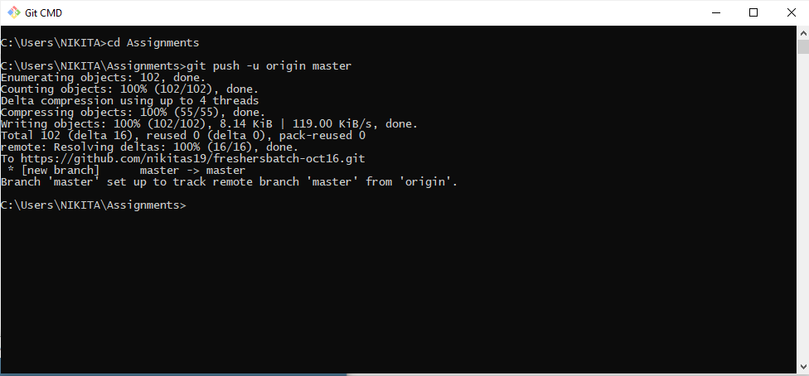

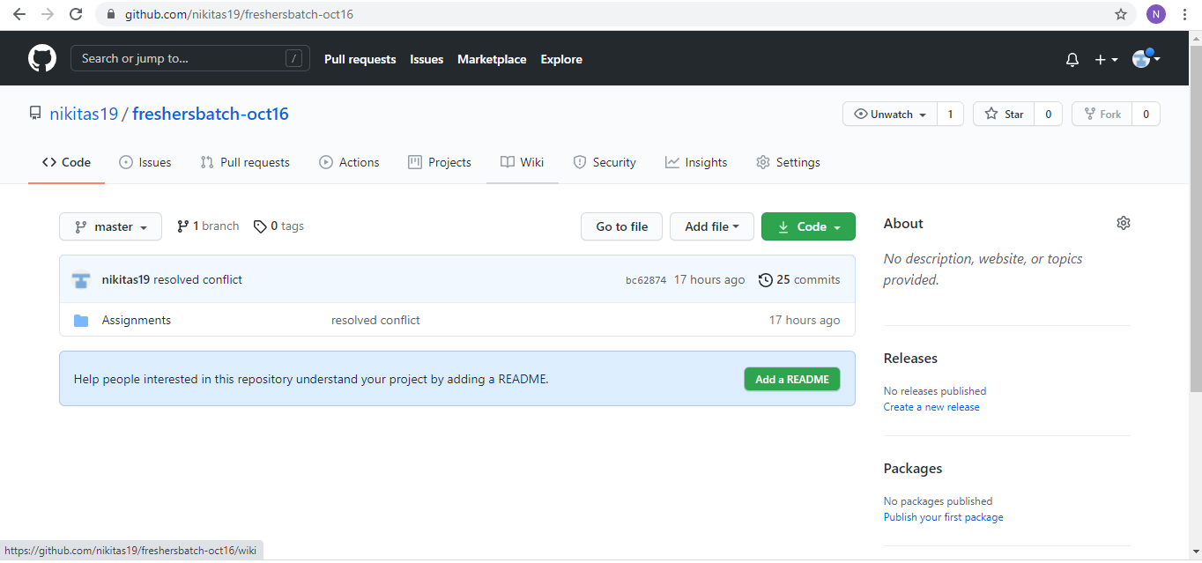

**Section 4**

